(Approx. 444 words)

What are you Tweeting?
By Linda Gonse, Editor / Webmaster, Orange County PCUG, California
December 2011 issue, nibbles & bits
www.orcopug.org
editor (at) orcopug.org

New users of Twitter sometimes get confused by the conventions commonly used in tweets. (Comments posted by Twitter users are called “tweets.”)

When you copy what someone else has tweeted and repost it for other people to read, it is called a “retweet.” Retweets not only pass along tweets you have found noteworthy, but gives credit publicly to the person who tweeted it.

Retweets are designated by tagging the beginning of a tweet with the capital letters “RT.”

If you see a tweet such as the one below, you might wonder what the tweet is all about.

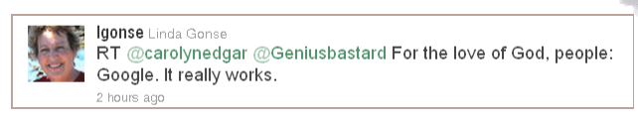

In the above example, it is a retweet of a retweet.

Confused? I’ll explain. The original writer’s user name is @carolynedgar. The person who retweeted her was @Geniusbastard. (The @ sign before a username links
a tweet to that account page.) The tweet itself was: For the love of God, people: Google. It really works.

I’ll digress here to explain the tweet itself. It’s clear that it’s written from exasperation. How many times do people ask where they can find something? Well, where do WE look to find something? Google. Right? But, you can tell people and you can tell them, and still they don’t think of Google first, or they believe it is easier to just ask someone else who uses Google!

Back to the tweet. When you retweet something that’s been retweeted, it is protocol to list it as a RT (retweet) from @(first person’s name) @(second person’s name). The tweet follows after the names.

Another way to handle a retweet of a tweet is to use RT @(first tweeter’s name) The tweet via @(second tweeter’s name). Example: RT @carolynedgar For the love of God, people: Google. It really works. Via @Geniusbastard.

Sometimes you can’t get a tweet to fit the 140 characters when including the retweet info. It’s okay to make judicious cuts or use abbreviations. When you do this, it is no longer a RT. You tag it as an MT (modified tweet). Also, if there is no extra room, you
can drop off the name of the last person who retweeted. In the case above, it is @Geniusbastard.

When you tweet something that someone might like to retweet, leave space in your tweet. This allows room for your username to be added if someone wants to retweet what you wrote. It is flattering to be publicly acknowledged, shows respect for your thoughts, and sometimes it attracts followers to the chronological list of your tweets, called your “timeline.”

